Car Moving Direction with Count & Probability:

Data Provided by Landeshauptstadt MAGDEBURG

Year : 2015

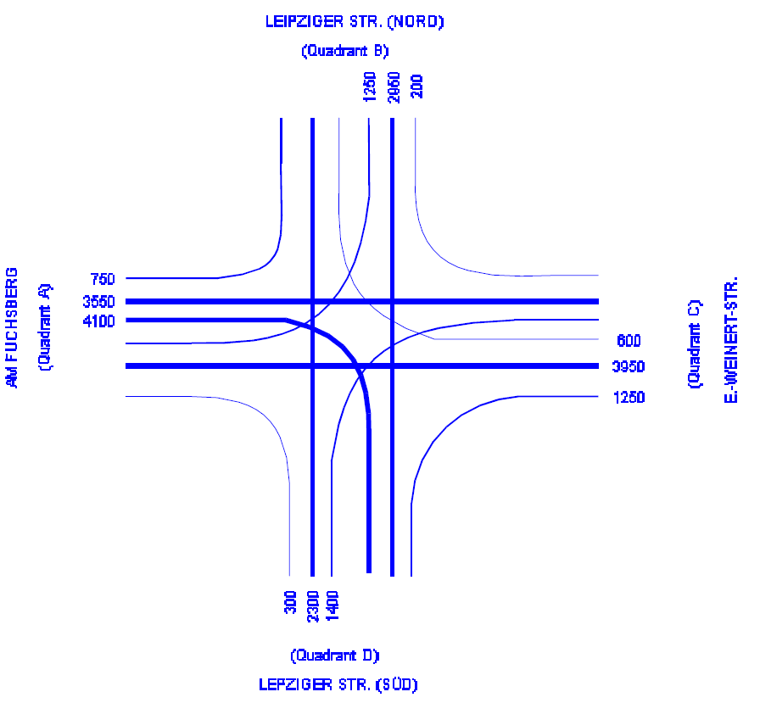

**AM Fuchsberg** to Lepzeiger strasse South - 300

Lepzeiger strasse North - 1250

Straight to EW strasse - 3950

--------------------------------------------------------------------------

Total - 5510

P1 = 300/5500 = 0.05

P2 = 1250/5510 = 0.23 af right =300+3950 ,pb to erw = 3950/4250=0.92

P3 = 3950/5510 = 0.72

---------------------------------------------------------------------------------------------------------------------

**Erich- Weinert strasse** to Lepzeiger strasse North - 200

Lepzeiger strasse South - 1400

Straight to Am Fuchsberg - 3550

--------------------------------------------------------------------------------

Total - 5150

P4 = 200/5150 = 0.04

P5 = 1400/5150 = 0.27

P6 = 3550/5150 = 0.69

-----------------------------------------------------------------------------------------------------------------------

**Lepzeiger strasse South** to Am Fuchsberg - 4100

To EW strasse - 1250

Straight to Lepzeiger strasse North - 2950 --------------------------------------------------------------------------------

Total - 8300

P7 = 4100/8300 = 0.49 LSS right total = 4200

P8 = 1250/8300 = 0.15 towards EWS =1250/4200=0.2976

P9 = 2950/8300 = 0.36

------------------------------------------------------------------------------------------------------------------------

**Lepzeiger strasse North** to Am Fuchsberg - 750

To EW strasse - 600

Straight to Lepzeiger strasse South - 2300 --------------------------------------------------------------------------------

Total - 3650

P10 = 750/3650 = 0.21

P11 = 600/3650 = 0.16 aumf left pb=750/3050=0.245

P12 = 2300/3650 = 0.63

------------------------------------------------------------------------------------------------------------------------